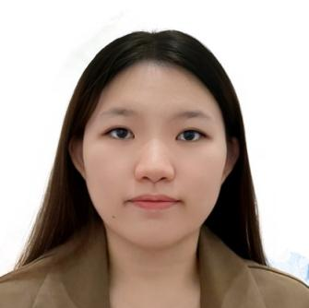
King Wen Joo
16, Jalan SS 13/4, Subang Jaya Industrial Estate,
47500 Subang Jaya, Selangor
+60 162014546 | kingwjoo04@gmail.com

SUMMARY
I’m a friendly, reliable person who enjoys working with people and creating a welcoming atmosphere. I’m quick to learn, stay calm when things get busy, and love being part of a team. I’m excited to grow my skills and contribute to a cafe where great service matters.

WORK HISTORY

WE Kitchen | Service Crew Nov 2022 - Jun 2024
- Balanced part-time work and studies, strengthening time management and problem-solving.
- Trained new staff members, improving team efficiency and reducing onboarding time

EDUCATION

MONASH UNIVERSITY | Bachelor of Computer Science (Advanced) July 2023 to now

SKILLS

Teamwork:

Comfortable working closely with others, supporting the team, and communicating.

Languages:

Fluent in Mandarin, English, and Malay

Problem-Solving:

Stay calm and find quick solutions when issues come up.

CLUBS & VOLUNTEERS

Monash Music Club | Member Jul 2024 – Nov 2024

Monash University Climbing Club | Member Jul 2024 – Present

Merdeka Charity Festival Run 2025 | Volunteer Aug 2025

World Singing Day 2025 | Volunteer Oct 2025

